Project Title: End-to-End Azure Data Engineering Pipeline
Project Overview
This project demonstrates a real-world data engineering scenario where on-premises data is migrated to the Azure Cloud, transformed, secured, and analysed to provide actionable business insights. The pipeline automates the movement of CRM sales data through a series of stages: ingestion, secure storage, large-scale transformation, and final reporting.
Architecture Diagram
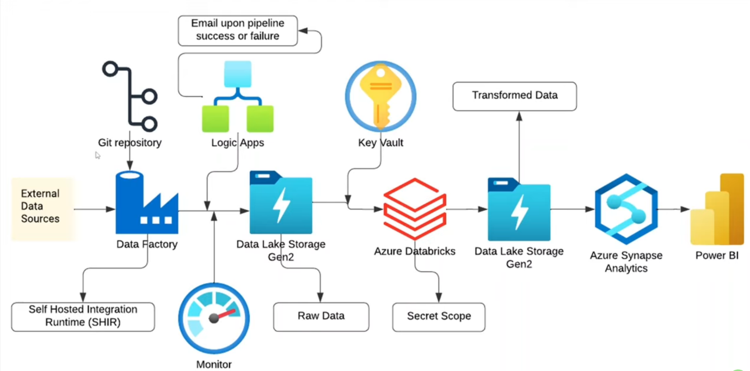
- On-Premises Source: Local CSV files representing CRM sales data.
- Ingestion: Azure Data Factory (ADF) using a Self-hosted Integration Runtime as a secure gateway.
- Data Lake: Azure Data Lake Storage Gen2 (ADLS Gen2) with hierarchical namespaces enabled, partitioned into raw-data and transformed-data.
- Security: Azure Key Vault and Databricks Secret Scopes to manage credentials without hardcoding.
- Transformation: Azure Databricks (PySpark) for cleaning, handling nulls, and formatting.
- Data Warehousing: Azure Synapse Analytics (Serverless SQL Pool) to create views and query processed data.
- Visualization: Power BI for interactive dashboarding.
- Monitoring & Alerts: Azure Logic Apps for email notifications and Azure Monitor for pipeline health.
Technologies & Tools Used
- Azure Data Factory: Orchestration and ingestion.
- Azure Databricks: Apache Spark-based data transformation.
- Azure Synapse Analytics: SQL-based analytics and data warehousing.
- Azure Data Lake Gen 2: Scalable cloud storage.
- Azure Key Vault: Secret management.
- Azure Logic Apps: Automated email alerts (Success/Failure).
- Azure Monitor: System-wide logging and metrics tracking.
- Power BI: Data visualization.
- GitHub: Version control and CI/CD for ADF pipelines.
Dataset Information
The project utilizes a CRM Sales Opportunities dataset containing five key tables:
- accounts: Company details, sectors, and revenue.
- products: Product names and sales prices.
- sales_pipeline: Sales agents, deal stages (Engaging, Won, Lost), and close values.
- sales_teams: Agent names and manager locations.
- data_dictionary: Explanatory metadata for columns.
Step-by-Step Implementation Guide
1. Infrastructure & Ingestion
- Set up a Resource Group and Storage Account (ADLS Gen2) with a Hot access tier.
- Install the Self-hosted Integration Runtime on the local machine to allow ADF to access on-prem files securely.
- Configure ADF Copy Activities to move CSV files from the local file system to the raw-data container.
2. Security & Version Control
- Integrate ADF with GitHub using a collaboration branch (dev) and a publish branch (adf_publish) for enterprise-grade version control.
- Create an Azure Key Vault to store the storage account access key as a secret.
- Link Key Vault to Databricks via a Secret Scope to ensure the code never exposes credentials.
3. Data Transformation (Databricks)
- Mount the ADLS Gen2 containers to Databricks using the secured credentials.
- Perform cleaning using PySpark:
  - Rename columns (e.g., "subsidiary of" to "parent company") for better readability.
  - Handle null values (e.g., filling missing account names with "unknown").
  - Overwrite the cleaned data into the transformed-data container in CSV format.
4. Analytics & Serving
- Provision an Azure Synapse Analytics workspace.
- Use a Serverless SQL Pool to create views (dbo.v_accounts, etc.) directly on top of the transformed files in the data lake.
- This allows for high-performance SQL queries without moving the data again.
5. Monitoring & Reporting
- Build a Logic App triggered by an HTTP request from ADF to send email alerts upon pipeline success or failure.
- Connect Power BI Desktop to ADLS Gen2 using the dfs endpoint and the storage access key.
- Develop a dashboard featuring:
  - Total Sales by Month (Line Chart).
  - Revenue by Sector (Donut Chart).
  - Win Rate Percentage (DAX Measure).
Key Best Practices Demonstrated
- Security: Using Key Vault and private backbone network routing (Microsoft network routing) rather than the public internet.
- Reliability: Implementing automated monitoring and soft-delete protections for storage.
- Scalability: Utilizing hierarchical namespaces in ADLS Gen2 for big data efficiency.
- CI/CD: Version-controlling ADF pipelines through GitHub integration.
How to Replicate
- Clone the repository and initialize the GitHub integration in your ADF workspace.
- Follow the setup steps for the Self-hosted Integration Runtime to connect your local data.
- Deploy the provided Databricks notebooks for the transformation logic.
- Execute the SQL scripts in Synapse to generate views.
- Open the Power BI template and refresh the data source with your storage URL.

Alerting message
To configure Azure Logic Apps for automated email alerts within your data pipeline, follow these steps as outlined in the sources:
1. Create the Logic App Resource
- Search for Logic Apps in the Azure Portal and create a new one.
- Select the Consumption hosting plan, which is ideal for small projects or demos as it is serverless and you only pay when the workflow runs.
- Assign it to your project’s Resource Group and choose your preferred region.
2. Define the Trigger (HTTP Request)
- Open the Logic App Designer and select the trigger "When an HTTP request is received".
- You must define the JSON schema for the data the pipeline will send. This typically includes properties such as:
  - pipelineName (string)
  - status (string)
  - ID (string)
  - time (string).
3. Configure the Email Action
- Add a new action and search for an email provider (the sources use Gmail as an example).
- Select "Send email" and authenticate with your email account.
- Set the Parameters:
  - Recipient: Enter the email address where notifications should be sent.
  - Subject: Provide a clear title, such as "Pipeline Run Report".
  - Body: Use the Dynamic Content tool to insert the fields defined in your HTTP trigger (Pipeline Name, Status, Run ID, and Time) so the email contains real-time details.
- Save the Logic App to generate a unique HTTP POST URL. Copy this URL for the next step.
4. Integrate with Azure Data Factory (ADF)
To make the pipeline actually send these alerts, you must add Web activities to your ADF pipeline:
- For Success Alerts: Add a Web activity named "Success". Paste the Logic App URL, set the method to POST, and use dynamic content in the Body to send the status as "Succeeded" along with the pipeline's run ID.
- For Failure Alerts: Add a second Web activity named "Fail". Use the same URL and POST method, but change the status in the body to "Failed".
- Connection: Chain these activities to the end of your pipeline. Connect the "Success" activity to the final task via a green (Success) path, and the "Fail" activity via a red (Failure) path.
By setting this up, the data engineering team remains informed about the pipeline health in real time.

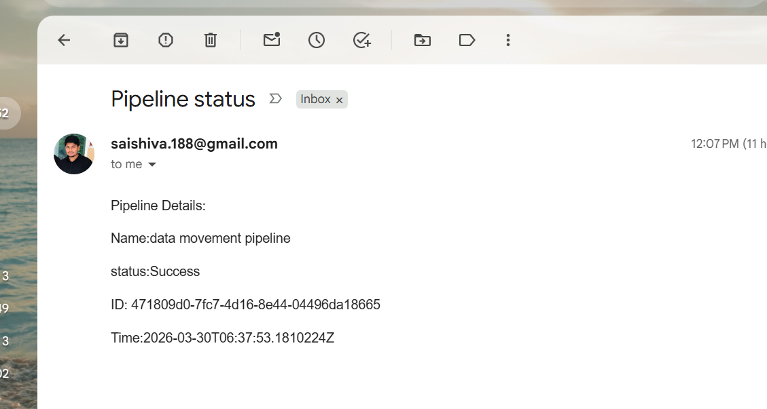

Power BI Dashboard:

